KDASC Webmaster’s Report – 2015 IASC State Convention 05.08.2015
James Leichty – KDASC Webmaster
KDASC Website: www.ilkdasc.weebly.com

Hello KDASC,

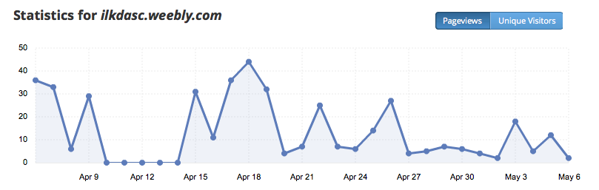
First off, I just would like to just like to start out by saying that I am very much looking forward to serving as your 2015-2016 KDASC Webmaster. Below, you will find information relating to the new KDASC website: www.ilkdasc.weebly.com since I have taken office. On the reverse side you will find the May 2015 calendar that is also available for viewing on the KDASC website.

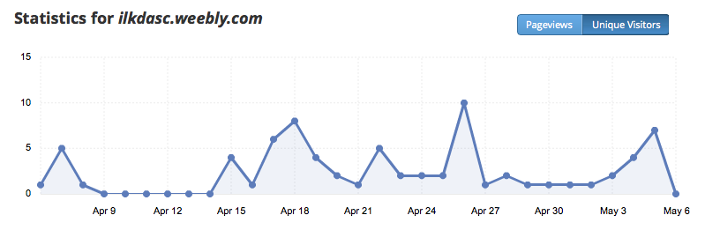

Features on the KDASC Website:
- calendar with KDASC events listed (updated monthly)
  - KDASC events listings (event, date/host school, and charity)
- registration forms available for print
- Kickapoo Cares ’15-’16 (be sure to check for the specific needs of certain charities)
- IASC website summary (includes upcoming IASC events/workshops)
- contact form (sent straight to my email)

In closing, I would like to encourage you all to check out the new KDASC website often for updates. I try to update the website every week as new information becomes available. Follow me on Twitter @KickapooStuco and @j_leichty50 and for quick and easy access to KDASC news.

Thanks,

James Leichty
KDASC Webmaster
Email: kdasc.web@gmail.com / jleichty23@gmail.com
Twitter: @KickapooStuco / @j_leichty50

On the reverse side, you will find the KDASC May 2015 calendar. These calendars will be updated monthly as new information becomes available.

