President
Ali Brann
Unity
alisynmykal12@yahoo.com

Vice-President
Lauren Ovca
Tuscola
lauren.ovca@gmail.com

Secretary
Olivia Christy
Tuscola
liv.christy96@gmail.com

Treasurer
Larissa Moses
Shiloh
mo6367@cell1net.net

State Liaison
Austin Dean
Atwood-Hammond
puff.dean@gmail.com

Historian
Allison Hemmer
Tuscola
arhemmer7@gmiail.com

Virtual Historian
Kaci Spry
kaci.spry@gmail.com

Convention Secretary
Emily Williams
Mahomet-Seymour
emily.williams197@gmail.com

Webmaster
Nick Appleby
Atwood-Hammond
jackson735@yahoo.com

Happy Halloween!!!
We hope everyone dressed up for the KDASC Halloween Dance 2011! With all of the stresses of the new school year, everyone deserves a break. Tonight’s festivities will include a phenomenal dance, some fantastic prizes, and a lot of fun. So get out there and show off your moves!

Blast from the Past:

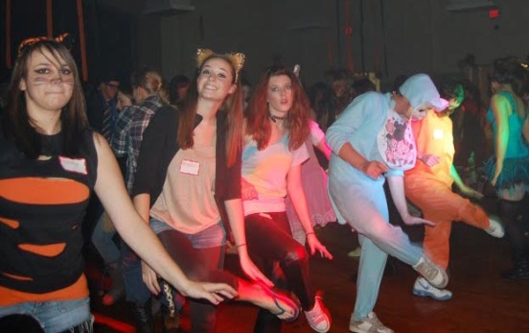

KDASC Halloween Dance 2009

Looking Back: Fall Picnic

Fall Picnic was a blast! We were so excited to see the huge turnout. In case you missed it, here is a brief overview of what we did…

Ice-breakers:
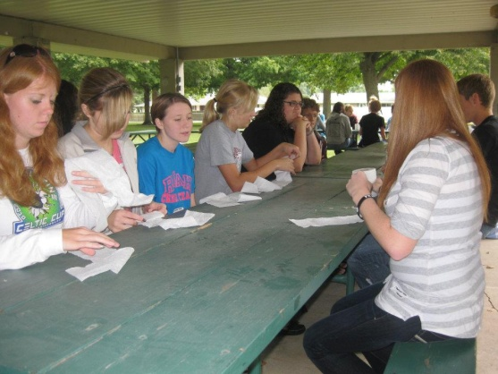
Human Tic-Tac-Toe:
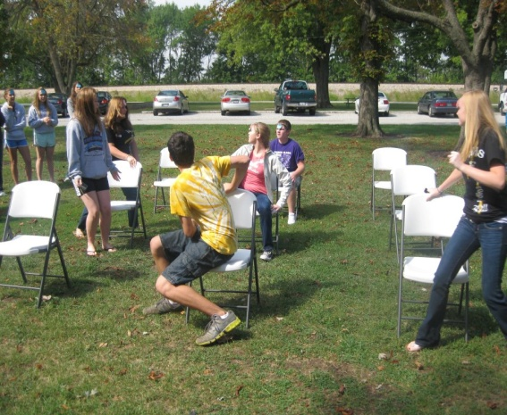
Make your own Homecoming dress competition:
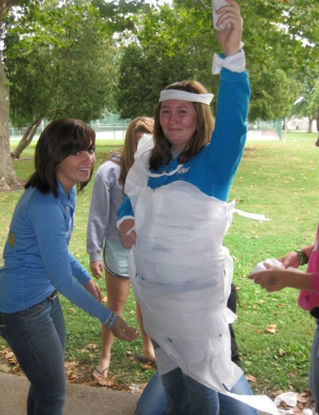
Scavenger Hunt:
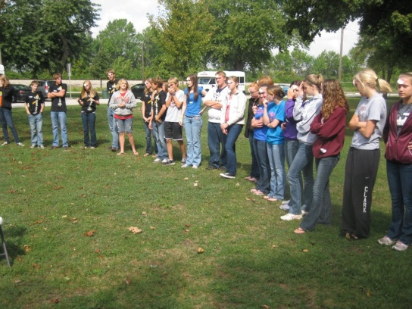
Not only did we have lovely weather and a good time, the KDASC donated a ton of items to give to the Cunningham Children’s Home. Thanks for all of your help!
What’s Coming Up?

Feed the turtles and get updates on the KDASC at our website!!!
Fall Retreat!
Our next event will be the KDASC Fall Retreat! The officers will be explaining their duties, as well as some of the perks of being a KDASC Officer. Make sure you attend this workshop if you think you may be interested in becoming an officer for the 2012-2013 school year! If you cannot make the workshop or if you have questions about a specific office, the email addresses of all the officers can be found on the first page.

Interested in IASC State Convention?
If you are interested in applying for a duty at this year’s IASC State Convention ask your advisor. There are many opportunities to get involved on the state level. Positions at state include: recorder, DGL, round table moderator, honor council, credentials committee, service projects. You can also apply to be a state officer. For more information check out the IASC website!

Stay tuned for the next newsletter! The KDASC officers will share a little about themselves!

Halloween Crossword Puzzle
